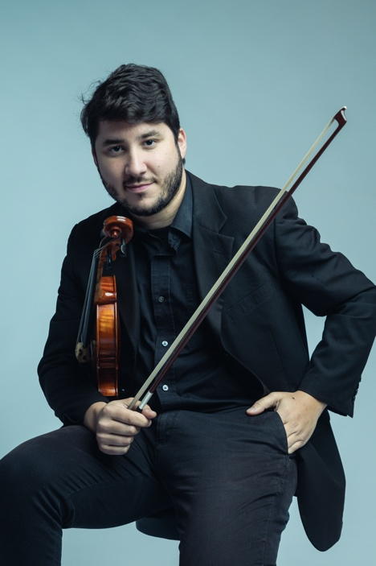Diego Núñez, a native of Maldonado, Uruguay, began his musical journey at the age of 9 through Uruguay's Children and Youth Orchestra Project. Excelling rapidly, he became the orchestra's concertmaster and later refined his skills at the Vicente Ascone School of Music under maestros Julio Levitas and Nicolas Giordano.

Joining the Sodre Symphony Orchestra in 2008, Diego performed at prestigious venues like Teatro Solís and Adela Reta, showcasing his violin proficiency across Uruguay. Awarded a scholarship in 2017, he pursued a Bachelor of Music degree in violin performance at East Tennessee State University, engaging in masterclasses and acclaimed festivals.

Diego's dedication led to roles in the Johnson City Orchestra and Symphony of the Mountains, earning recognition in the MTMA Competition 2020. In 2021, he completed his master's studies at the University of Tennessee, Knoxville, mentored by Professor Miroslav Hristov.

Currently, Diego enriches the Montevideo Philharmonic Orchestra with his musical talents. His versatile artistry extends beyond classical music, collaborating with esteemed ensembles such as "Tango X 3" and the internationally acclaimed "Orquesta Típica del Río de la Plata." His performances grace prestigious venues both domestically and internationally, including Teatro Adela Reta, Teatro Solís, Sala Zitarroza, and Teatro Maccio, leaving an indelible mark on the music landscape.